**EC2 Instance Creation**

1] Search for EC2 and click **launch instance**

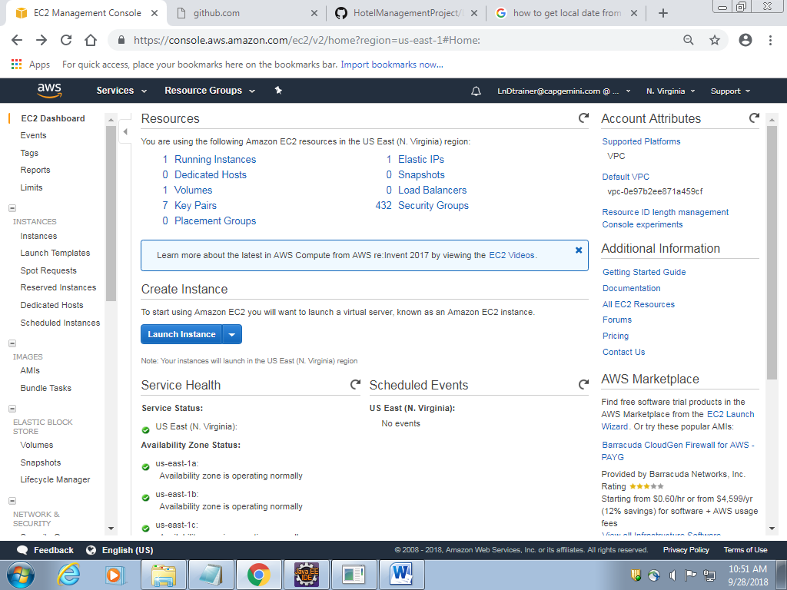

2] Click select for second link

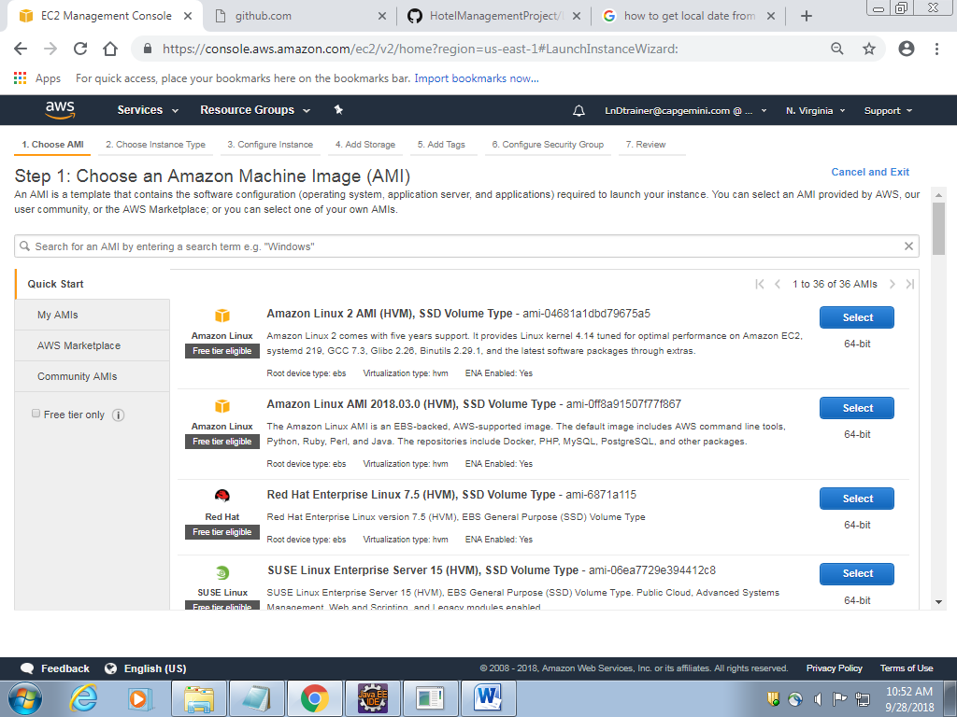

3] Click **Configure instance details**

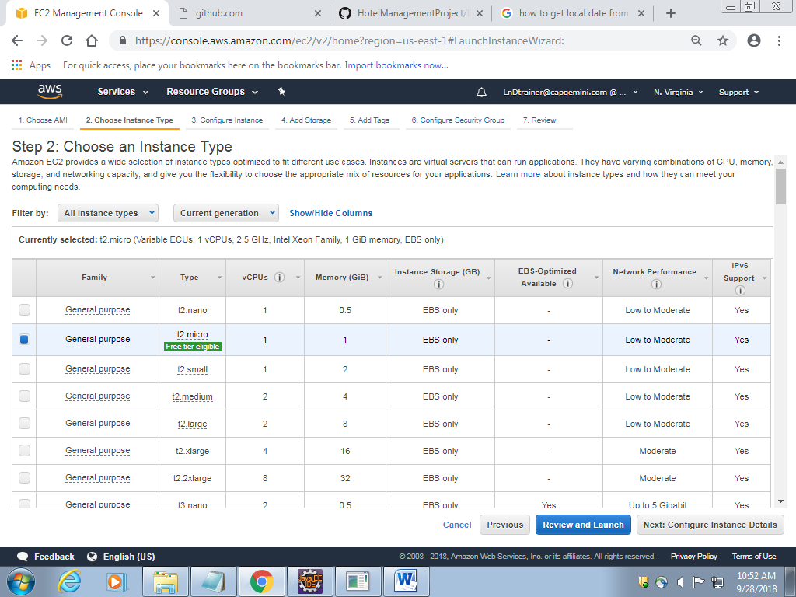

4] Click **Add Storage button**

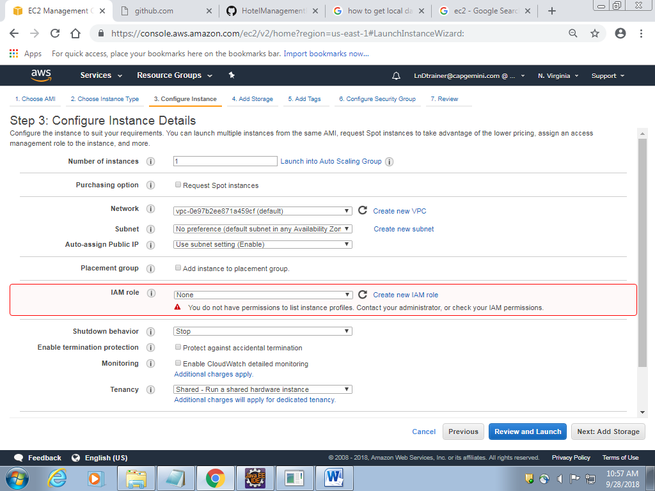

5] Click **Add Tags**

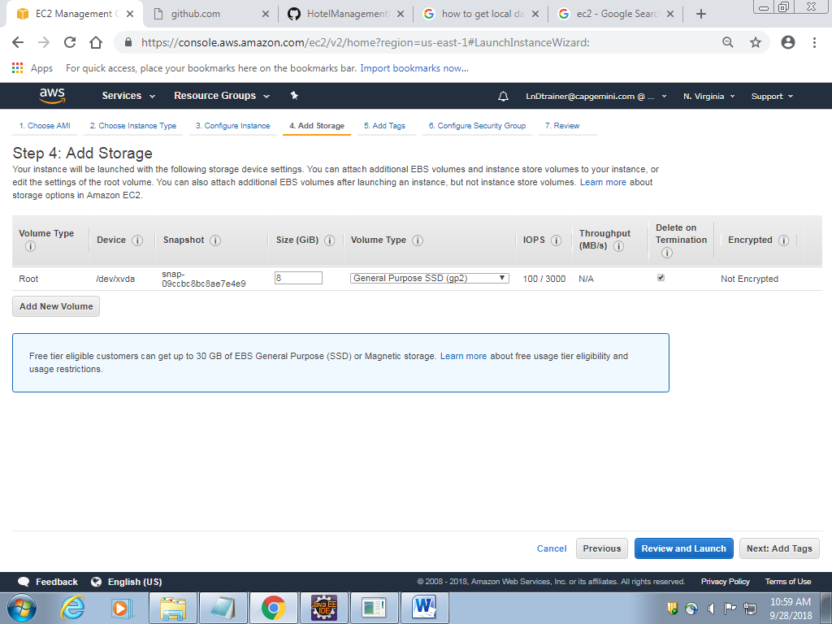

6] Click Add Tag--> Enter Key as **key-keyname** And value as **value-valuename**--> Click on configure security group

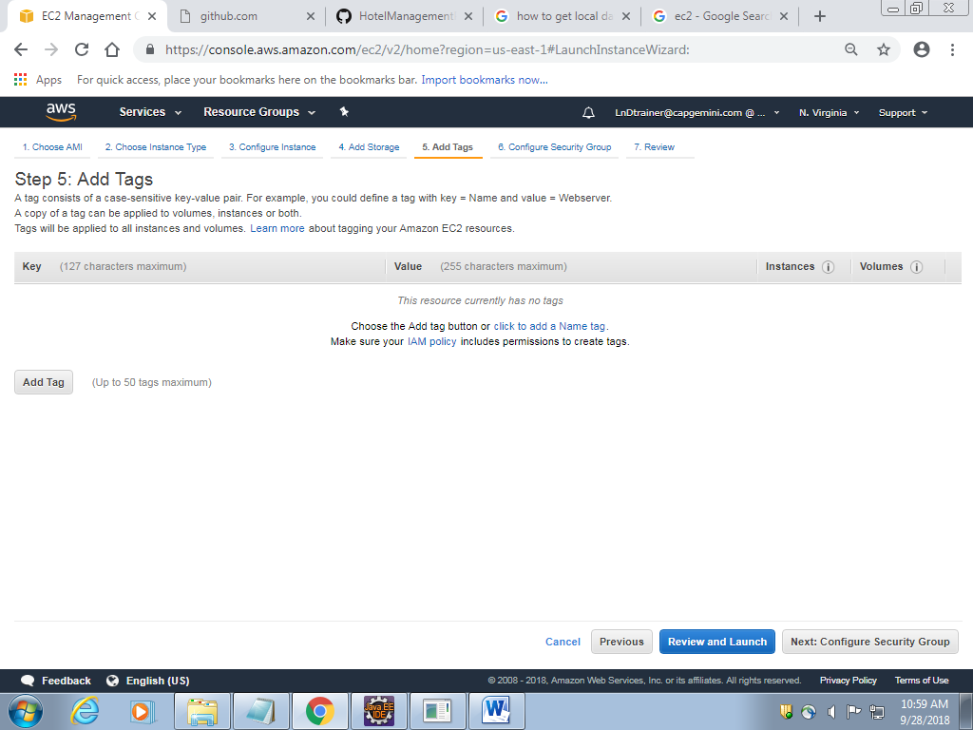

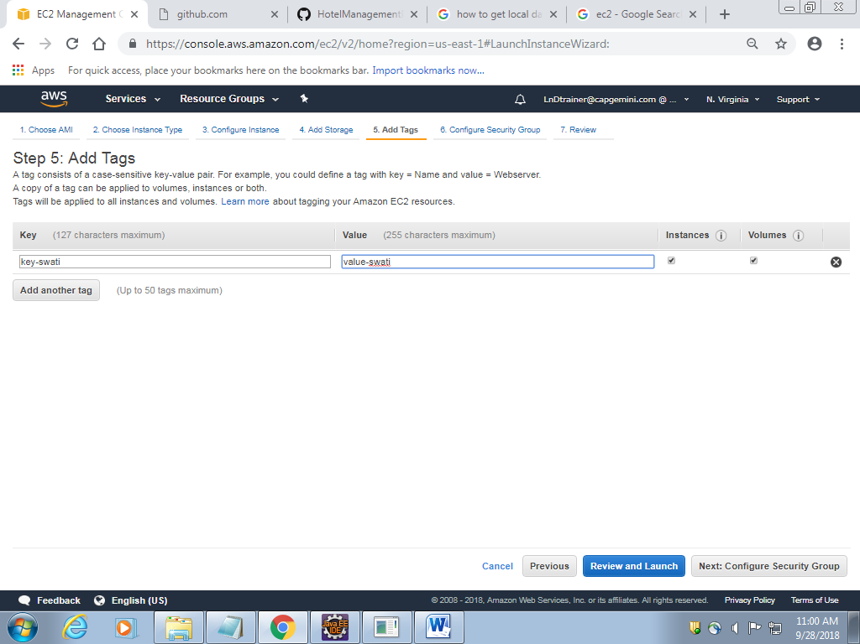

7] Add Rule--> **HTTP and HTTPS**--> change source to **Anywhere**--> click **Review and Launch**

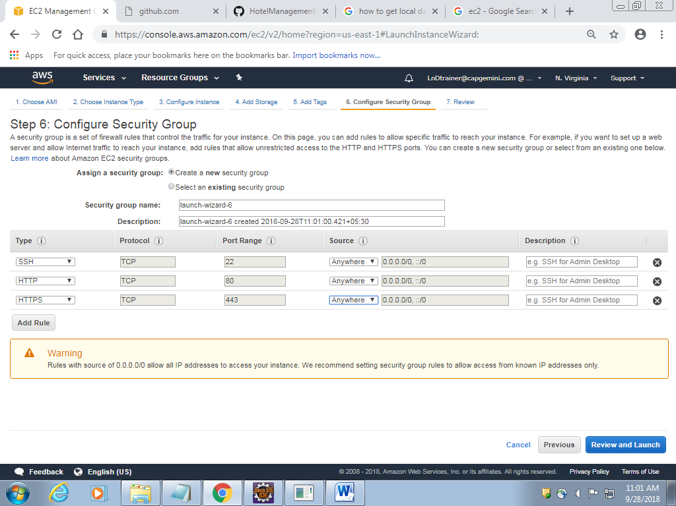

8] Click on **launch**

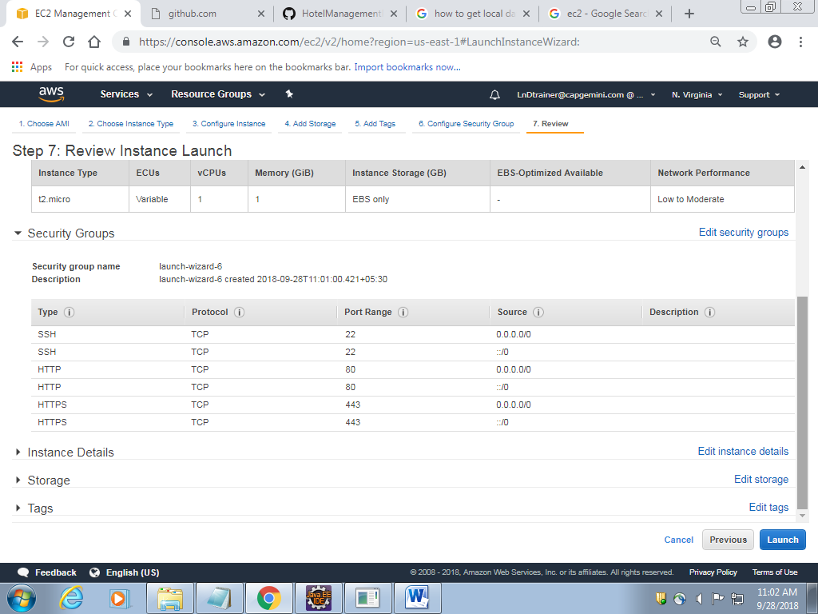

9] **Create new key pair**--> Enter pair name as **key-keyname**--> **download key pair**-->click **launch instance**

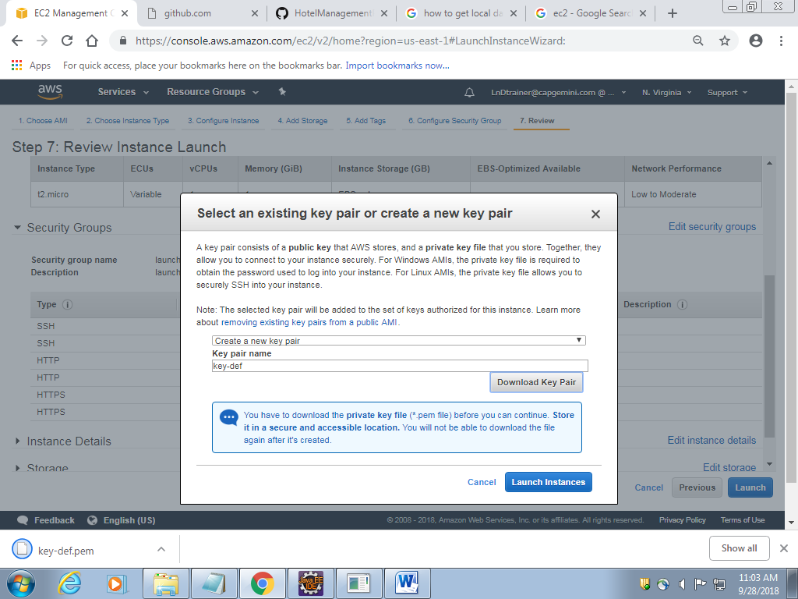

10] Click on **View instance**

